HEALTH DATA ANALYSIS

Capstone Project
By
ANJITHA LAKSHMI G S
AI-Driven Data Analysis
Abstract
Healthcare data analysis plays an important role in understanding patient information and identifying meaningful patterns that can support better healthcare decision-making. This project focuses on analyzing a provided healthcare dataset using Python to extract useful insights from patient records.
The dataset contains information such as patient age, gender, diagnosis, symptoms, treatment, medical history, and other related details. Python libraries such as Pandas, NumPy, Matplotlib, and Seaborn are used for data cleaning, preprocessing, analysis, and visualization. The process includes handling missing values, checking duplicate records, organizing data, and performing exploratory data analysis (EDA).
The analysis explores patient age distribution, gender distribution, common diagnoses, symptoms, and treatment patterns. Graphs and visualizations are used to present the findings clearly and make the data easier to understand.

- Introduction
This project focuses on analyzing a healthcare-related dataset using Python . The main aim is to understand the structure and quality of the data, clean it appropriately, explore patterns using statistical summaries, and communicate the results through charts and tables. The analysis is descriptive and is intended to understand the records in the dataset, not to provide medical advice or prove that one factor causes another.
2. Project Objective
The objective is to demonstrate an end-to-end data analysis workflow using Pandas, NumPy, Matplotlib, and Seaborn. The work includes loading the dataset, examining rows and columns, checking data types and missing values, preprocessing the data, carrying out exploratory data analysis (EDA), creating visualizations, and summarizing the findings.
3. Dataset Overview
The dataset was loaded into Google Colab using Pandas and the read_csv() function. The initial view showed 2,182 rows and 13 columns. The visible fields include patient_id, age, gender, Diagnosis, Remarks, doctor_id, Patient History, age_group, and gender_numeric, along with other healthcare-related fields. The exact column names were checked in Colab before analysis.
Functions such as head(), shape, dtypes, info(), and describe() were used to understand the first few records, dataset dimensions, column data types, non-null values, and statistical summaries.
- Data Preprocessing
Data preprocessing was performed to improve consistency and prepare the data for analysis: Missing values were checked with isnull().sum(). The initial screenshot showed 4 missing values in age and 4 in doctor_id. Missing age values were filled using the median age, after converting the age field to a numeric type and checking for implausible values.
Missing doctor_id values were kept missing because doctor_id is an identifier, filling it with a median could create misleading IDs. Duplicate rows were checked and removed when present. A separate cleaned copy was used so that the original dataset remained available. An age_band column was created to group records into age ranges. Where the symptoms column was available, a symptom_count column was created by counting the listed symptoms. The cleaned dataset was saved separately as health_data_cleaned.csv.
5. Exploratory Data Analysis (EDA)
Exploratory Data Analysis is the process of examining data to identify distributions, common categories, possible relationships, and unusual values. The project includes the following forms of analysis:
5.1 Univariate Analysis
Univariate analysis studies one variable at a time. The age distribution is examined using descriptive statistics and a histogram. Gender and diagnosis frequencies are summarized using value_counts() and bar charts. This helps show which values or categories occur most often in the dataset.
5.2 Bivariate Analysis
Bivariate analysis compares two variables. A box plot can compare age distributions across gender groups, and a cross-tabulation can compare gender counts across diagnosis categories. These comparisons help describe differences between groups but do not establish causation.
5.3 Groupby and Pivot Tables
Groupby summaries calculate statistics such as the number of records, average age, and median age for each gender group. Pivot tables summarize record counts across age bands and gender. These tables make it easier to compare groups in a structured format.
5.4 Multivariate Analysis and Correlation
A correlation matrix and heatmap are used to examine associations among selected numeric or coded variables, such as age, age_group, and gender_numeric, if those columns exist. Coded categorical variables must be interpreted cautiously. Correlation does not prove a cause-and-effect relationship.
6. Data Visualization
Matplotlib and Seaborn are used to present the data visually. The notebook includes a histogram for age, bar charts for gender and diagnosis counts, a box plot for comparing age groups, a heatmap for correlations, a scatter plot for age versus symptom count when available, and a pie chart for gender distribution. Each chart includes a meaningful title and appropriate axis labels where applicable.

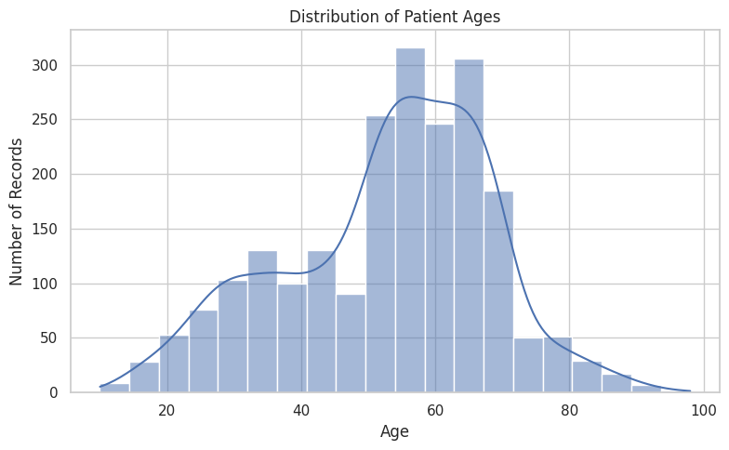

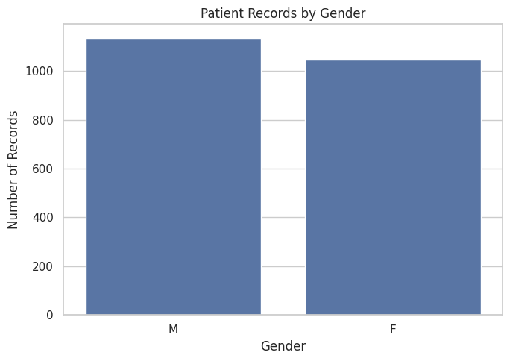

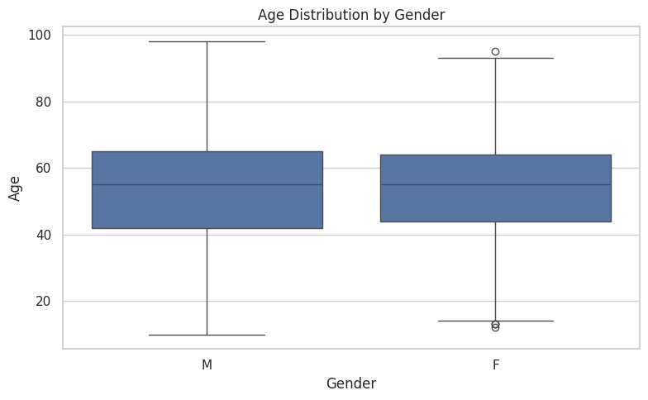
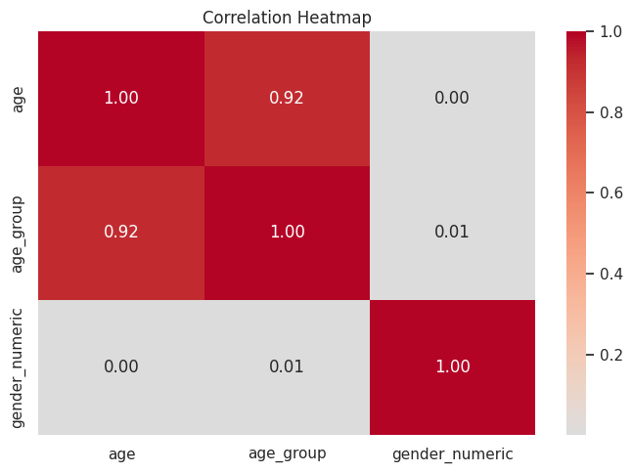

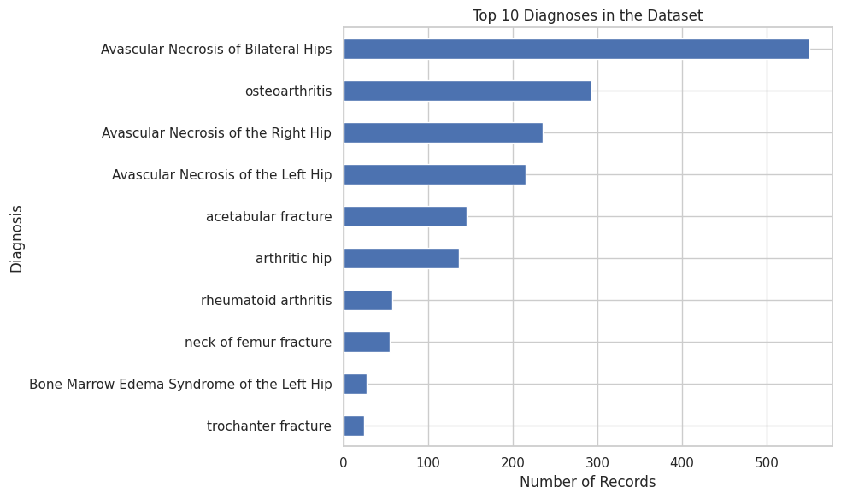

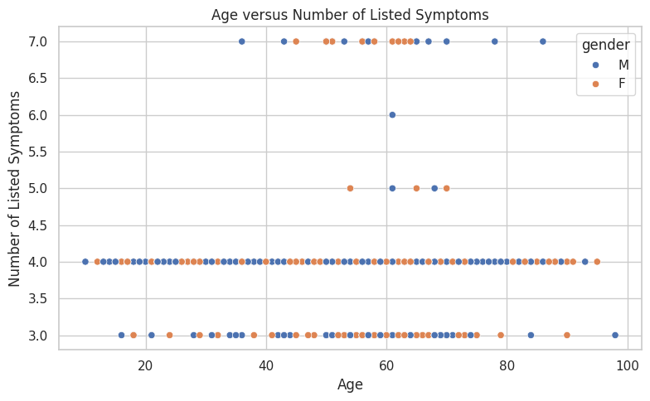

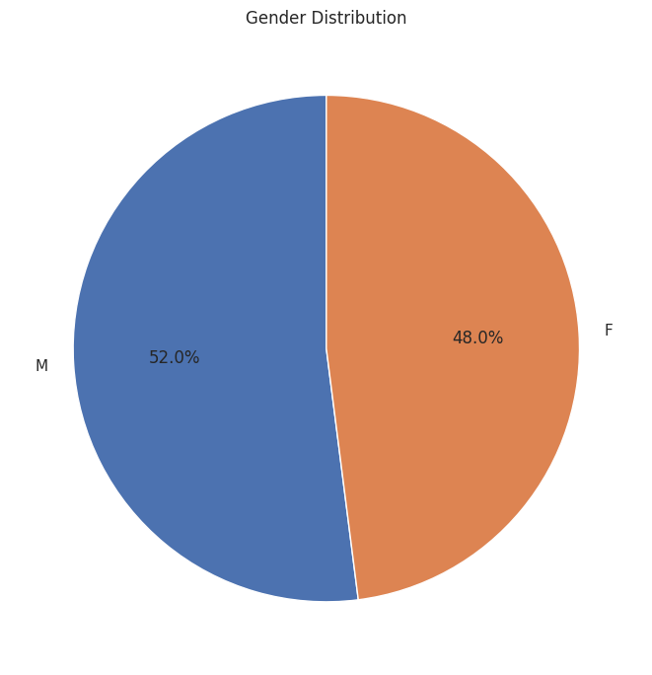

7. Insight Generation and Interpretation
The final summary cell calculates findings from the cleaned data, including the dataset Healthcare Data Analysis Project |dimensions, mean and median age, gender counts, and the most frequent diagnoses. These values should be read from the actual outputs produced by running the notebook. The most common category represents the largest count in this dataset; it should not automatically be interpreted as the most common condition in the wider population. Treatment counts, if examined, indicate how often treatment labels appear in the records. They do not show whether a treatment is effective, because effectiveness would require a suitable study design and additional clinical information.
8. Conclusion
This project demonstrates a complete data analysis workflow using Python in Google Colab. The dataset is loaded and reviewed, data quality is checked, missing age values are handled, duplicate records are checked, and derived fields are created where appropriate. EDA is carried out using descriptive statistics, groupby operations, pivot tables, correlation analysis, and multiple visualizations. The final findings describe patterns within the available records. Further analysis would benefit from verified definitions of all columns and confirmation of the dataset's source and limitations.
9. Limitations of the Project
- The results depend on the quality and completeness of the dataset.
- The dataset may not represent the entire population, so the findings cannot automatically be generalized to all patients.
- Missing values and inconsistent records may affect the results.
10. References
- Data set : Health data set(2180 rows & 13 columns)
- Web : Google Dataset

